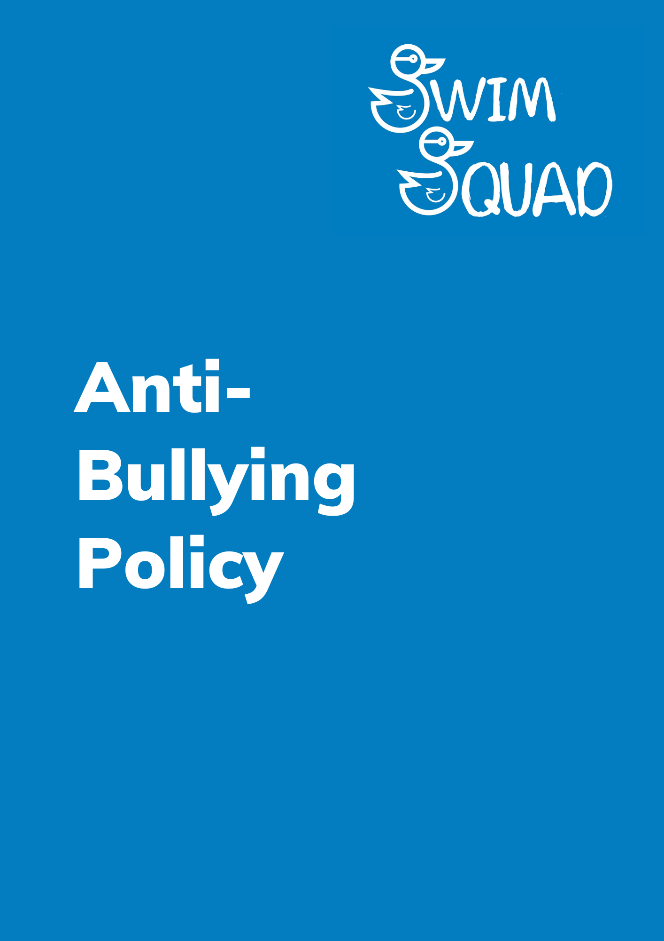
Purpose
At Swim Squad, we are committed to fostering a nurturing, welcoming, and safe environment for all our swimmers, ensuring they can enjoy a relaxed and secure swimming experience. We firmly stand against any form of bullying; considering it entirely unacceptable.
In the unfortunate event that bullying does take place, we encourage all swimmers and parents to feel confident in reporting such incidents, knowing that we will address them promptly and effectively. Transparency and openness are fundamental values in our company, and we firmly believe that everyone should have a voice.
This means that anyone who becomes aware of bullying occurring is expected to communicate this to their swimming teacher or the on-duty manager without hesitation. We are dedicated to upholding these principles and maintaining a safe and supportive atmosphere for all.

What is bullying?
Bullying is characterised by the deliberate use of aggressive behaviour with the explicit intention of causing harm or distress to another person. This harm can manifest in various forms, including emotional and physical pain, which inflicts significant distress on the victim.
At Swim Squad, we are resolute in our stance against bullying and are committed to creating an environment where all individuals can thrive without fear of such harmful behaviour.
Bullying can be:
- Emotional – being unfriendly, excluding (emotionally and physically), sending hurtful text messages, tormenting, (e.g. hiding goggles / floats, threatening gestures).
- Physical – pushing, kicking, hitting, punching or any use of violence.
- Racist – racial taunts, graffiti, gestures.
- Sexual – unwanted physical contact or sexually abusive comments.
- Homophobic – because of, or focusing on the issue of sexuality.
- Verbal – name-calling, sarcasm, spreading rumours, teasing.
- Cyberbullying - This involves the use of digital technology to harass, threaten, or embarrass someone.
- Isolation- Deliberately excluding someone from group activities, social circles, or conversations during swimming lessons.
- Intimidation - includes using threats, gestures, or other means to create fear or discomfort in another swimmer.
- Body Shaming - Comments or actions that focus on a person's body size or appearance can be considered a form of bullying.

- Age-Based Bullying - In a swimming lesson environment with a mix of age groups, older swimmers may target younger ones through teasing, belittling, or exploiting their age-related vulnerabilities.
- Online Harassment - While similar to cyberbullying, online harassment specifically involves persistent and malicious online actions, such as trolling, stalking, or making threats, often through social media or online forums.
It's important to address all forms of bullying promptly and appropriately to ensure a safe and supportive environment for all swimmers. Encouraging open communication and educating swimmers and parents about what constitutes bullying and how to report it is crucial in preventing and addressing these issues effectively.
Reporting bullying
In the initial occurrence of any bullying incidents, we kindly request that you promptly report them to your swimming teacher. Your teacher will take the necessary steps to address the situation and work towards a resolution.
Nonetheless, if you find that the issue has not been satisfactorily resolved or if you have reservations about how the matter has been handled, please do not hesitate to escalate your complaint by contacting us via email at admin@swimsquad.co.uk. Rest assured that we are fully dedicated to addressing all concerns with diligence and efficiency.
Your well-being and safety remain our top priorities, and we treat such matters with the utmost seriousness. We are here to ensure that any issues you encounter are effectively resolved, maintaining a secure and supportive environment for all our swimmers. Your feedback and concerns are valuable to us, and we are committed to their prompt and thorough resolution.
Monitoring and Review
We will monitor all feedback that we receive in relation to the issues affected by the Policy and will amend the policy as necessary. The Policy will be updated with any amendments to existing legislation or new legislation.
In any event, all policies are reviewed annually although updates to versions, etc. will only take place every three years should there be no other changes to the policy.
The next date for review will be September 2024.

